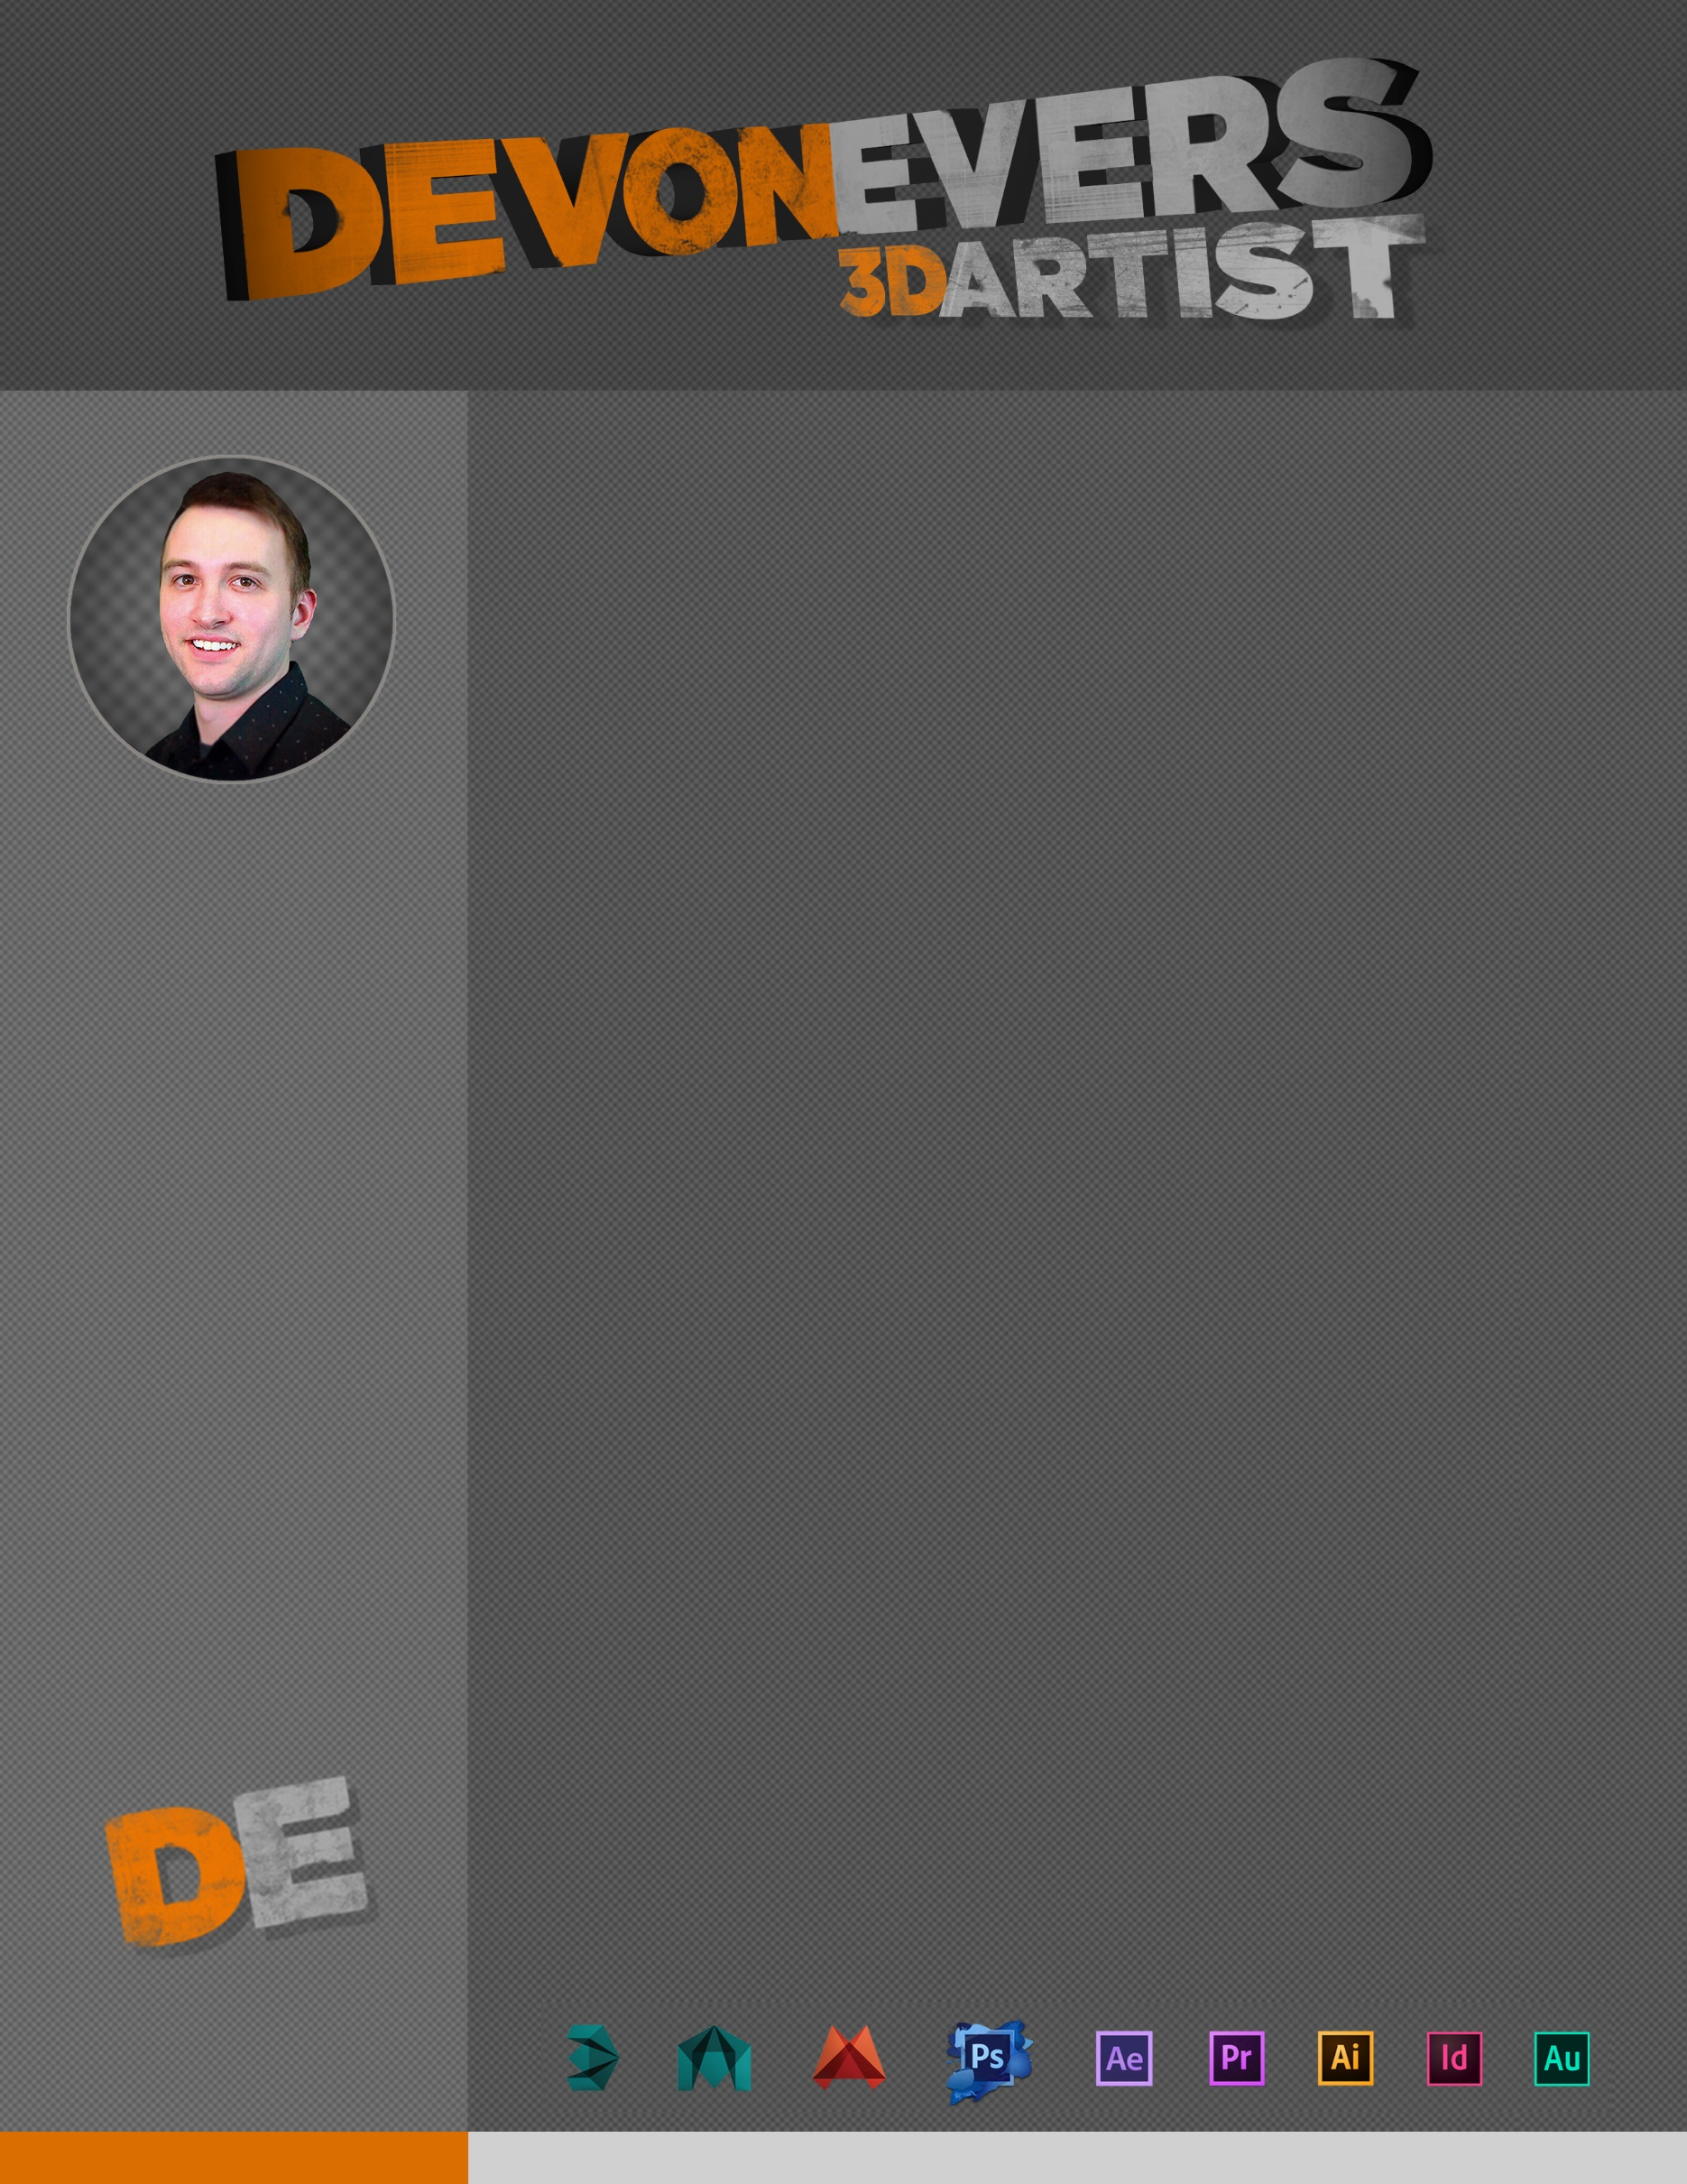

• Work with various companies to develop 2D & 3D videos as well as photo realistic renderings based on the client’s requirements using Autodesk 3Ds Max

• Conduct interviews for potential hires

• Manage new hires & delegate projects based on the individual’s specific skills

• Work within aggressive deadlines, and use time management to manage an annual target of $300,000 for the marketing department

• Use my personal equipment for all videography & photography projects

• Supervise a team of interns to develop a series of videos based on the client’s requirements

• Organize brainstorming sessions to discuss the production pipeline

• Conduct interviews for potential hires

• Work under tight deadlines that require significant after hours work and a strong attention to detail

• Create high poly 3D models and environments using Autodesk Maya

• Work with a team of individuals to create 3D videos & renderings in a professional work environment

(647)-981-8014

devonevers.com

24 Mabelle Ave,

Toronto, ON

M9A 4X7

PROFILE

Contact

evers.devon@gmail.com

Passionate 3D Artist with a strong background in 2D & 3D design. I am also a self-taught videographer & photographer

References available upon request

Humber Institute of Technology and Advanced Learning

• Post-Graduate Certificate for 3D Production: Game Art & Design 2011 – 2012

• Diploma in Multi Media 3D Animation 2009-2011

EDUCATION

• Modelling • Animation • 3D Sculpting • Motion Graphics

• Texturing • Compositing • Videography • Graphic Design

• Lighting • Rendering • Photography

EXPERTISE & SKILLS

WORK EXPERIENCE

Allied Technical Solutions – 3D Generalist March 2014 - Present

Bell Canada – 3D Generalist/Team Lead January 2013 – February 2014

• 3Ds Max • Maya • Mudbox • Photoshop • After Effects • Premiere

• Illustrator • InDesign • Audition

SOFTWARE

Updated June 17th 2019